S. Dhakshin Kumar
15-2804/2A, Bharath Nagar, Chittoor, Andhra Pradesh
E-mail: sukkadhakshin@gmail.com
Cell: 8309236622
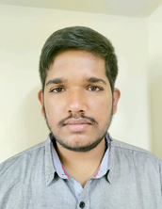
CAREER OBJECTIVE
As a motivated student currently pursuing a degree in computer science and engineering.
I am eager to gain hands on experience and apply my academic knowledge in a real-world setting.
I am passionate about new technologies. Seeking an opportunity to learn and grow professionally.

ACADEMIC

COURSE | INSTITUTE / UNIVERSITY | YEAR OF  PASSING | GRADE /  PERCENTAGE
PG (please  specify) | -
UG (please  specify) | AMRITA VISHWA VIDYA PEETHAM BENGALURU,KARNATAKA | 2025 | 6.86
+2 / Intermediate /  PUC / HSc | SRI CHAITHANAYA RAMAN BHAVAN -1 &2 VIJAYAWADA , KRISHNA DISTRICT,ANDHRA PRADESH | 2021 | 81%
10th | DR KKR GOWTHAM SCHOOL, GUDIVADA, KRISHNA DISTRICT, ANDHRA PRADESH | 2019 | 9.8

PROJECTS

. Topic: Plant Disease Detection Using AI
. Duration/Period: 2024
. Tools or techniques used: Kaggle notebook, Visual Studio Code.
. Outcome: Successfully designed a website for the farmers so they can identify the disease easily.

. Topic: Legal Text Documentation and case outcome prediction
. Duration/Period: 2023
. Tools or techniques used: Jupitor Note book, Excel(For dataset population)
. Outcome: Successfully trained a model (X G Boost ) for the faster case outcome prediction.

. Topic: Exploring Network Paradigms: A QoS Analysis Perspective .
. Duration/Period: 2023.
. Tools or techniques used: Jupitor Notebook,Kaggle.
. Outcome: Successfully Compared the Client server model and Peer to peer view model.

. Topic: Cloud Native Monitoring Application Using Promothus
. Duration/Period: 2024.
. Tools or techniques used: AWS,Promethus,Gafana,Visual Studio, Docker Desktop.
. Outcome: Successfully Monitored a application Using Promotheus and gafana.
PROFESSIONAL CERTIFICATION
I have done certification in coursera on supervised machine learning in classification and
regression and Unsupervised learning . And some certifications on Cloud computing in AWS
on Cloud Introduction,Cloud Foundations , and Cloud Security Foundations.
DOMAIN RELATED TECHNICAL SKILLS
Domain Knowledge:- Operating System, Machine Learning, Introduction to Data Science ,
Computer Security, Ethical Hacking, DBMS.
Programming Languages:- Java(intermediate level ) , C++(intermediate level), Python(basic)

PAPERS PRESENTED / PUBLISHED / WORKSHOPS / SEMINARS

My Paper Title:- Exploring Network Paradigms: A QoS Analysis Perspective
Got Accepted by conference named 15 th ICCNT 2024.
ACHIEVEMENTS AND AWARDS / EXTRACURRICULAR ACHIEVEMENTS

Call of Duty Mobile Campions In University Level Tournments

HOBBIES

Playing Indoor Games and Outdoor Games like Kabbadi, Cricket, Badminton and Reading
Newspaper, Seeing Movies .

PERSONAL DETAILS
Date of Birth : 29-07-2004

Languages Known : Telugu, Hindi, English
Permanent Address : 15-2804/2A, Bharath Nagar, Greamspet, Chittoor,Andhra
Pradesh, India,517002

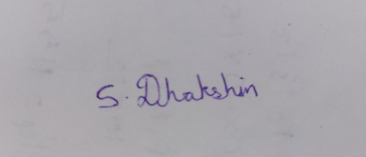

{SUKKA DHAKSHIN KUMAR}

